Cities of Antonica

Information from EQAtlas.com
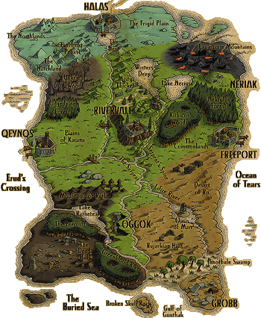
FreePort

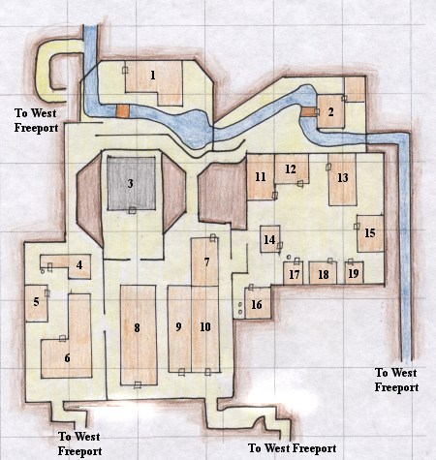
North Freeport

1 Office of Landholders
2 Hall of Truth - the Paladin Guild
3 Temple of Mithaniel Marr - Guilds for the Clerics and Paladins
4 Groflah's Forger - sells Ore, Weapons, Clay, Steel Boning, Sharpening Stones, Forge outside door
5 Marsheart's Chords - Bard Guild Hall, selling Throwing Weapons and Musical Instruments
6 Freeport City Hall
7 Coalition of Trade Folks - sells Food items
8 Guard House
9 Empty Building
10 "The Blue Building" - sells jewelry crafting items
11 Jade Tiger Den - sells Food Items
12 Tassle's Tavern - sells Alcohol, Brew Barrel inside
13 Emporium - sells Medium Cloth items, Forge outside door
14 Empty Building
15 Bank of Freeport
16 Tavern - sells Food Items, has Brew Barrel and Oven inside and Pottery Wheel and Kiln outside
17 Empty Building with Oven outside
18 General Goods - sells Food items
19 Clothier Shop - sells Pottery Sketches and Cloth armor

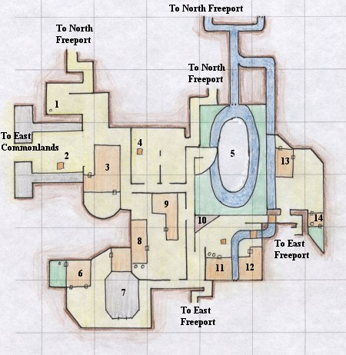
West Freeport

1 Lady selling Brewing Supplies
2 Ogre selling Pickled Items, also Ping Fizzlecutter nearby selling Tinkering Supplies
3 Freeport Militia
4 Lady selling Cloth Armor
5 Magician, Enchanger, and Wizard Guild - sells Tomes, Gems, and Violet Robes
6 Warrior Guild - sells Various Weapons, Forge out back
7 Arena - PvP area
8 Smithy - sells Various Weapons, Pottery Wheel inside and Kiln outside
9 Hogcaller's Inn - sells Alcohol, Lady Shae inside, Brew Barrel inside
10 The Stage
11 Brownloe Bakery - sells Food Items and Bowls, Kiln and Pottery Wheel outside
12 Ashen Order - Monk Guild Hall, sell Throwing Weapons and Musical Instruments
13 Torlig's Herbs and Medicines - sells Potions, Crystals, Mistletoe
14 Empty Building - Oven inside

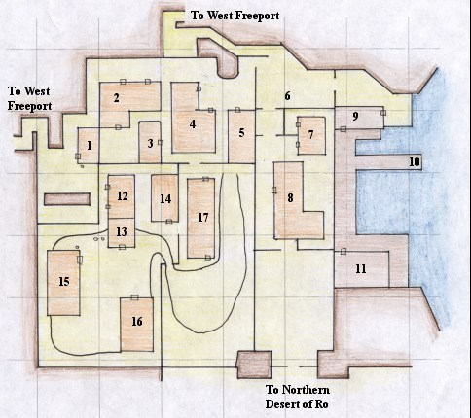
East Freeport

1 Armor by Ikthar - sells Chain and Plate Armor, Armor Molds, Clay, Forge outside
2 Trader's Holiday - sells Blacksmithing Molds and Books, Alcohol, Brew Barrel and Oven inside
3 Tavern - sells Alcohol
4 Felith and Bard Imported Goods - sells Alcohol, Blacksmithing Books, File molds and other molds
5 Leather and Hide - sells Small and Medium Leather Armor and Patterns
6 Priest of Discord
7 Grub and Grog Tavern - sells Alcohol, has Brew Barrel and Oven inside
8 Freeport Inn - sells Food Items, Lanterns, other goods
9 Port Authority - sells Fishing Supplies
10 The Dock for boat to Ocean of Tears, Butcherblock Mountains, and the rest of Faydwer
11 Seafarer's Roost - sells Odd and Unusual Beers, Brew Barrel inside
12 Inn - secret entrance to the underground tunnels with Necromancer, Shadow Knight,
and Rogue guilds, as well as Guildmaster for the other classes for evil races
13 Empty Building
14 Empty Building
15 Gord's Smithy - sells Various Weapons and Bags
16 Chops and Hops - sells Alcohol, has Oven inside
17 Hallard's Resales - sells Various Weapons, also KOS dog named Scraps
FreePort

Location:
On the east coast of Antonica, this port city lies at the intersection of the Commonlands and the great Desert of Ro.

Races:
Human, Half Elf

Guilds:
Bards, Clerics, Enchanters, Magicians, Monks, Necromancers, Paladins, Rogues, Shadow Knights, Warriors, Wizards

Religious Facilities:
Mithaniel Marr, Erollisi Marr, Innoruuk (Human/Half-Elf)

Artisan Facilities:
Brew Barrel, Forges, Kiln, Ovens, Pottery Wheel, items and equipment for all but Fletching and Tinkering

Description

Freeport is considered by most to be the hub of Antonica for a variety of reasons. It is the mercantile center of the continent, since it holds the only port with a regular boat to the island continent of Faydwer. It holds facilities for most of the artisan trades, and most budding craftsman travel to Freeport to take advantage of the readily available facilities. Freeport is also the hub for traffic of all sorts. The good races travel its streets to go to their guilds and the shops, as well as to the boat to Faydwer, and the dark races travel through the sewers to reach most of the same destinations. Guild Halls for all classes except the Rangers, Druids,
and Shamans are present within the city.

Surrounding Areas

Freeport lies at the intersection of several notable areas of Antonica. To the west of Freeport lies the Commonlands, a vast tract of forested plains that are ringed by desert. In that direction lie the other large cities of the humans, Highhold Keep and Qeynos, and more distantly the homes of the barbarians and the Erudites.

To the south of Freeport lies the vast Desert of Ro, which stretches south until it reaches the swamps of the ogres and trolls. This vast untamed desert still holds the sand giants and Dervish Cutthroats that have made it dangerous to travel for generations.

To the east of Freeport lies the vast Ocean of Tears, and it is over this ocean that the ships of the humans travel to provide trade to the distant land of the dwarves, elves, and gnomes.

Travelling To and From Freeport

Freeport can be reached from the east from across the Ocean of Tears by the ships that regularly travel the route. From the south, one travels to the Northern Desert of Ro and from there into East Freeport. From the west, one travels to the easternmost part of the Commonlands, and from there into West Freeport.

Local Color

Places

Freeport is a city of many layers, both good and bad, as one would expect from a town so busy and so large. The tunnels beneath the city allow the dark races to connect to the various areas of the city, including their dark guilds as well as the docks. Certain parts of the city are relatively unsafe, the worst is in East Freeport at the bazaar. The guards in the area are unaware of what goes on just below the surface, and one will commonly see dark elves travelling through the area. This is also where the surface access to the guilds hidden from the rest of the city are located.

Other places of note are the Temple of Mithaniel Marr in North Freeport, which is laid out in the whitest granite, and very different than the rest of the city, as well as the guild hall of the magic users, a wonderful floating structure over a small pond, with teleporters as its only access. Most of the shops lie in North Freeport around the vicinity of the bank, and in East Freeport.

People

The people in Freeport are as varied as the town itself. Travelling through the city one can see an entire range of races, including ogres and dark elves, humans and elves, and various beggars in between. Also, it is not uncommon to see several of the more powerful members of their guilds travelling through Freeport on their ways to other places, or engaged in some transaction.

The guards of Freeport constantly roam the corridors, and to the naked eye could be considered normal guards. Beneath the surface, however, the paladins of Mithaniel Marr secretly hunt the guards, for they are corrupt, and, as rumors have it, their leader was a banished paladin himself.
Neriak

Foreign Quarter

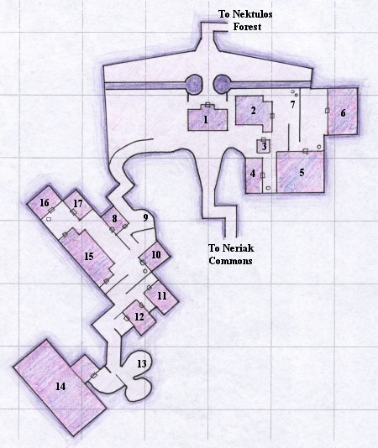1 Guard Hall
2 The Smugglers Inn - sells Alcohol, all Brewing and Pottery Supplies, Food Items and other goods
3 Silk Underground - sells Cloth Armor and Sewing Kits
4 Dranas Bread and Butcher - sells Food Items and Cooking Supplies, Oven outside
5 Slugs Tavern - sells Alcohol, Brew Barrel outside
6 Market View - sells Alcohol, all Brewing and Pottery Supplies, Food Items and other goods
7 Merchants who sell Shoes and Bags, as well as Kiln and Pottery Wheel
8 Merchant who sells Various Weapons
9 Two Ogres who sell all Blacksmithing books, File Molds and other Molds
10 Armor Shop selling Large Ringmail Armor, Forge outside
11 Pig Stickers - sells Various Weapons
12 Empty Building
13 Merchant who sells Shaman Spells (? still in game)
14 Neriak Overlook
15 PvP Area, Merchants who sell Food and other Goods and Alcohol
16 Bites n Pieces - sells Food Items and other goods, Oven outside
17 Shinie Tings - sells metal for Jewelcraft

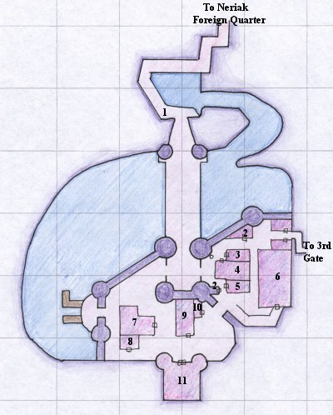
Commons

1 Priest of Discord
2 Entrance to the Neriak Underground - found within is the Neriak Bank, The Burnished Coin, The Refined
Palate, The Bounty of the Earth, and the Blind Fish, these places sell between them Sharpening Stones, Clay,
Ore, Alcohol, Food Items and other Books, Cooking Supplies, Potions and Magic Stones, also has Brew
Barrel and Oven
3 Smithy - sells Ringmail Armor and Various Weapons
4 Adamant Armor - sells Plate Armor
5 Forge House - sells Alcohol
6 Wizard, Magician, and Enchanter Guild Hall - sells all items for those classes
7 Toadstools - sells Alcohol and Small Armor Molds, Fishing Supplies sold outside
8 The Bleek Fletcher - sells Fletching supplies
9 The House of D'abth - sells Food Items and other goods
10 The Dashing Form - sells Cloth Armor and Sewing Kits and Patterns
11 Warriors Guild Hall
Note the above map is missing a secret area that lies behind the waterfall north of 1, and a Wizard Rod spawns
as well

Third Gate

1 Temple of Innoruuk - Cleric Guild Hall, sells Blunt Weapons
2 Necromancer and ShadowKnight Guild Hall - sells appropriate equipment for these
classes
3 Library - sells Various Spells, including Wizard Portal spells, Enchanter Vision and
Enchant metal spells sold by Mizr N`Mar, and Magician Summon spells
4 Furrier Royale - sells Small Leather Armor, Patterns and Kit
5 Rogue Guild Hall
6 The Maidens Fancy - sells Alcohol, Brew Barrel inside, also has Dark Elf
Ambassador and Ironforge Prisoner
7 The Bauble - sells gems for Jewelcraft
8 Cuisine Excelsior - sells Alcohol
9 The Rack - sells Wine
10 Empty Buildings
11 X'Lottl Private Mansion
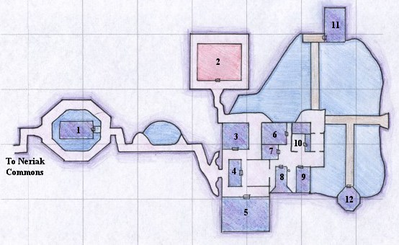
12 J'Narus Private Mansion
Neriak

Location:
On the northeastern corner of Antonica, hidden in the Nektulos Forest

Races:
Dark Elf

Guilds:
Clerics, Enchanters, Magicians, Necromancers, Rogues, Shadow Knights, Warriors, Wizards

Religious Facilities:
Innoruuk

Artisan Facilities:
Brew Barrel, Forges, Kiln, Ovens, Pottery Wheel, items and equipment for all but Fletching and Tinkering

Description

Neriak is the center of the Dark Elven empire, and is a splendid, dark city that lies carved out of the mountians next to the Nektulos Forest. No natural light
has ever seen their homeland, and the dark elves thrive and flourish in their city. All manner of evil races, including the Trolls and Ogres, can be found within.
Most of these are restricted to the Foreign Quarter, where the dark elves trade with the outside world. The deeper parts of the city house many of the city's
shops, guild halls, and homes.

Surrounding Areas

Neriak lies off of the Nektulos Forest, a barely alive forest that is continuously in the dark from the smoke drifting down from the volcanic Lavastorm
Mountains to the north. To the south of the forest lies the Commonlands and the homes of their enemies, the humans.

Travelling To and From Neriak

Neriak can be reached only by travelling through the Nektulos Forest to its well-guarded entrance. To the north of the forest lies the broken Lavastorm
Mountains and the lair of the great dragon, Lord Nagafen, as well as the Temple of Solusek Ro. To the south of the forest lies the Commonlands, and from
them the human cities of Freeport, Highhold Keep, and the lands beyond.

Local Color

Places

Neriak is a twisted, but beautiful, city, carved out of the earth millenia ago. Magic and excellent artisanship have lit up the city with glowing neon-colored
lights, and fountains and monuments to the god of the dark elves, Innoruuk, fill the city.

People

The city of Neriak, for all of its beauty, is filled with danger, as befits its occupants. Stepping into the wrong place in any part of the city can easily get you
killed, and this is especially true for the Trolls and Ogres, who, although guests, are not welcome everywhere. This could be from some degree of superiority
on the dark elves part, and also because of the plot the dark elves are hatching, lying barely hidden beneath the surface of the city.
Qeynos

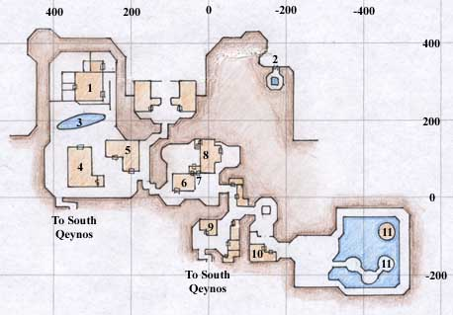
North Qeynos

1 Order of the Silent Fist - Monk Guild, merchant who sells Monk Weapons, Bags, and
Bandages
2 Kliknik Tunnel - leads to Qeynos Underground
3 Reflecting Pond - tunnel leads to Qeynos Underground
4 Crow's Pub & Casino - Merchant selling Alcohol, Brew Barrel, secret tunnel to Thieves Guild
5 Galliway's Trading Post - Merchants selling Food and other Goods
6 Ironforge's - Merchants selling Sharp Weapons and Medicine Bags
7 Jewelbox - Merchants selling Jewelry supplies (Metals and Gems)
8 Ironforges' Estate
9 The Cobbler - Merchant selling Boots of all types
10 Merchants selling Blunt Weapons and Cleric/Paladin spells
11 Teleport leading to Temple of Life, Cleric and Paladin Trainers throughout area

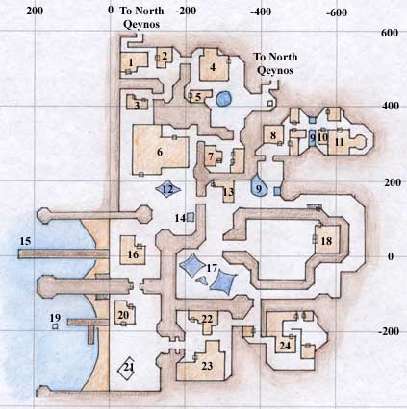
South Qeynos

1 Tin Soldier - Forge outside, Merchant selling Medium Chain Armor
2 The Wind Spirit's Song - Bard Guild Hall, Merchants selling Bard songs and various Weapons
3 Fharn's Leather & Thread - Merchant selling Medium Leather Armor and Small Sewing Kit
and Patterns
4 Bag n Barrel - Merchants selling Bags, Pottery Wheel and Kiln out back
5 Nesiff's Wooden Weapons - Merchants selling Blunt Weapons, outside Merchant selling
Arrows and Arrow Supplies
6 Lion's Mane Inn - Merchants selling Alcohol, Brew Barrel
7 Tax Hall
8 Qeynos Hold - Bank
9 Underwater tunnel to Qeynos Underground
10 The Herb Jar - Merchants selling Spells, Potions, Books, Magic Stones, and Magician
Equipment
11 Wizard, Enchanter, and Magician Guild Hall, Trainers and Merchants selling Spells and
Wizard Equipment
12 Tent Merchants selling Small Leather and Ringmail Armor and Medium Cloth Armor
13 Fireprides - Merchants selling Medium Plate, Chain and Leather Armor and Shields
14 Tent Merchant selling Large Leather and Ringmail Armor and Large Shields, Forge outside
15 Boat Dock
16 Mermaid's Lure - Merchant selling Fishing Supplies
17 Tent Merchants selling Cloth Armor, Small Sewing Kits, Bags, Axes, and Sharp Weapons
(including Claymore)
18 Warrior Training Hall inside the Grounds of Fate (PvP Area), underground tunnel leads to
Qeynos Underground (follow the bones)
19 Underwater tunnel to Qeynos Underground
20 Port Authority
21 Merchant selling Instrument Parts, Spells, Compass, and Fish
22 Voleen's Fine Baked Goods - Merchants selling Food, Brewing Supplies, some Cooking Supplies, Oven inside
23 Fish's Ale - Merchants selling Alcohol, Brew Barrel inside
24 Temple of Thunder - Paladin and Cleric Trainers, Merchants selling Spells, Various Weapons, and Shields of all sizes
Qeynos

Location:
On the middle of the western coast of Norrath, west of the Plains of Karana.

Races:
Human, Half-elf

Guilds:
Bard, Cleric, Enchanter, Magician, Monk, Necromancer, Paladin, Rogue, Shadow Knight, Warrior, Wizard

Religious Facilities:
The Temple of Life, House of Thunder

Artisan Facilities:
Brewery, Forge, Kiln, Oven, Pottery Wheel

Description

Qeynos is one of the largest cities in all of Norrath, and one of the two large coastal cities run by the humans. The docks of the city provide trade from Qeynos to the high human city of Erudin, as well as to other areas along the coast. The Guards of Qeynos command posts throughout the surrounding terrain, providing protection to travellers as far away the the Plains of Karana. Most of the major guilds are present in this town, and it is the home of the Clanhouse of the Silent Fist. There is a seamy underbelly to this city, like other port cities, and rumors of corruption and smuggling as well as unsavory street dwellers are a part of everyday life here. There are many (some say too many) drinking establishments within the high walls of the city.

Surrounding Areas

The Gates of Qeynos are a bustle of activity. Many young explorers practice their weapon skills on the sewer creatures that inhabit the area, as well as on the Klikniks, which have an as yet undiscovered hive near the city of Qeynos. More dangerous creatures are fended off by the city guard, and the gnolls from nearby Blackburrow occasionally make assaults on the gates.

Further from the gates are the Hills of Qeynos, an area jointly patrolled by Guards of Qeynos and the rangers and druids of Surefall Glade. These hills are more dangerous to the traveller, and wild animals roam freely. Haunted ruins dot the landscape, and the hideous entrance to the dark hole of Blackburrow juts out of the cliff face here.

Travelling To and From Qeynos

Qeynos is a major hub of travel on the western coast of Norrath. It is the only major port which receives regular traffic from Erudin, our human brothers to the west. A great deal of mystical knowledge is gained through this alliance. We are separated from our barbarian brothers in the northlands by the savage gnolls of Blackburrow, but many of them battle their way through to see the lands south of their home. We maintain a strong alliance with the rangers and druids of Surefall Glade, though they prefer to stay clear of our streets and buildings.

To the east, however, lies vast uncharted territory. The human city of Freeport might as well lie on the sun as on our very continent, for no traveller has managed to create an ocean route to that port, and overland travel either takes the traveller through the savage swamps of the ogres and trolls or through the Plains of Karana and lands further to the east, which are populated by bandits and giants, as well as other creatures that defy description. Our City Guard maintains posts in the Plains of Karana, but they are scattered and only extend into the western edge of this vast area.

Local Color

Places

There are four main pubs in town, Lion's Mane Tavern, Mermaid's Lure, Fish's Ale, and Crow's Pub and Casino. This list is roughly in order of decreasing politeness of the inhabitants. The Lion's Mane is an average quality pub, serving drinks in an amiable atmosphere, relatively close to the docks. Mermaid's Lure is directly on the docks, sports an aquatic decor (including odor) and the crowd that goes along with it. Fish's Ale is near the docks, and draws a clientele similar to Crow's, but is better kept. Crow's, despite being next to the sanctity of the Silent Fist Clan and their reflecting pool, sports the most unsavory of crowds. None of them would even speak to me other than to call me scum the last time I was there. The only redeeming point about the place is that you can brew your own alcohol in the back, but I personally wouldn't, who knows if they clean that thing.

The Wind Spirit's Song is my personal place, being the home to the League of Antonican Bards, the songs and poems that drift out the door entice me to return home whenever I find myself singing to an unenlightened crowd.

The Grounds of Fate provide entertainment of the bloody sort, where warriors vie against monsters captured by the guards to the cries of fans. Truly gruesome.

People

There are many odd people in town, some of which you should hold onto your purse more tightly around. In fact, it's wisest to hold onto your purse until proven otherwise. One such individual who I speak with often is Merkes Tabolet, who can be found roaming the docks trading in his speciality (which happens to be everything). His goods are very handy, and he's an interesting soul, but I don't open my purse in front of him, if you get my meaning...
Rivervale
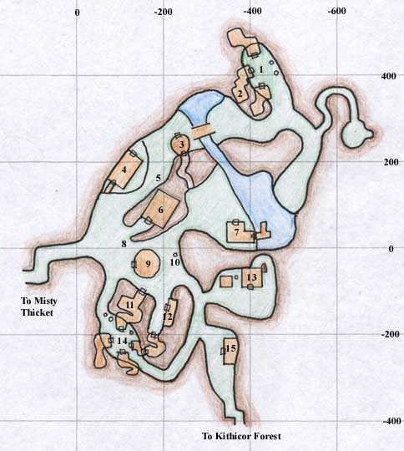
1 Pottery Wheel and Kiln
2 Nyla Gubbin's House
3 Selling Bags and Fishing Supplies
4 Weary Foot Rest - Inn
5 Bard
6 Town Hall and Leatherfoot Hall - Bank, Warrior Guild, Various Weapons

7 Sells Food and other Goods, Fishing Supplies
8 Priest of Discord
9 Rogue Guild
10 Brew Barrel
11 Sells Potions
12 Sells Leather Armor and Patterns, Small Chain Armor
13 Druid Guild - Sells Veggies, Forge and Oven outside
14 Pottery Wheel, Oven, and Forge

15 Cleric Guild - Sells Blunt Weapons

Location:
Nestled between the Misty Thicket and the Kithicor Woods in the center of
Antonica

Races:
Halfling

Guilds:
Clerics, Druids, Rogues, Warriors

Religious Facilities:
Bristlebane

Artisan Facilities:
Forge, Kiln, Oven, Pottery Wheel

Description

Rivervale is a quiet town, hidden well in the valley surrounding a small lake that is the head of a river running through Antonica. The layout of the town is simple,
with tunnels burrowed through rock as its entrances and the river running out through a narrow, unpassable gorge. Rivervale itself is separated into the town
itself where most people live, the docks, and the farms, where the druids work and the clergy pray.

Surrounding Areas

The Misty Thicket has several huts of more intrepid salespeople trying to reach the crowd of people that pass through this area between Freeport and Qeynos.
The area is also rampant with insects, as well as tougher creatures past the wall.

Kithicor Forest itself is much closer to the usual route between the two coasts, and sees more of the urban travellers. It is also much more dangerous. I haven't
spent much time there, just passing through on the beat of my drum...

Travelling To and From Rivervale

Rivervale can be accessed from one side through the Kithicor Forest through a narrow, well-hidden tunnel. The other side opens onto the Misty Thicket, where
many halflings make their homes. This area is generally a little safer for the traveller, but further afield lies areas best avoided.

Local Color

Places

The town is very quaint, with holes where the halfings live and do business, as well as larger businesses that seem built to house more of the taller folk, like the
local bar. Also, one of the largest and most well-kept inns lies in this green glade, with a warm hearth for everyone who passes its mantle.

People

The people in Rivervale are very easy to get along with. Most of them like to talk, and will speak with anyone who walks by. Of course, if you are evil or
working for the forces of same, don't expect a friendly reception by the town guard.
Surefall Glade
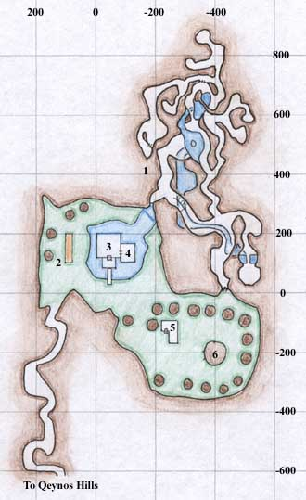
1 The Caves filled with Bears and Mammoth
2 Archery Range with Ranger Trainer and Merchant who sells Arrow-making Supplies
3 Ranger Hall with Ranger Guildmaster and Bard
4 Shop with Ranger Trainer and Merchants who sell Bow-making Supplies, Bows, Throwing Weapons, Spells,
Sharp Weapons, Food and Other Goods
5 Jaggedpine Treefolk with Druid Trainer and Merchants who sell Arrow-making Supplies, Druid Weapons,
Spells, Food and Other Goods
6 Druid Guildmaster

Location:
On the middle of the western coast of Norrath, west of the Plains of Karana.

Races:
Human, Half-elf

Guilds:
Druid, Ranger

Religious Facilities:
None

Artisan Facilities:
None

Description

Surefall Glade is the haven for the Rangers and Druids of the western coast of Antonica. Nestled in a beautiful waterfell-fed dale filled with the rare large trees of jaggedpine, these lovers of nature, along with the residents of the nearby Qeynos, are at constant battle with destroyers of nature, the worst of which are the nearby Blackburrow Clan of Gnolls.

Surrounding Areas

Qeynos Hills lies through a narrow tunnel that connects to the Glade. This area of grassy hills to the north of Qeynos is the main battleground between the
humans and half-elves and the gnolls of Blackburrow. The druids and rangers maintain, along with the guards of Qeynos, patrols around the region, although
they haven't been enough to curb the tide of gnolls. This area is also teeming with animals that the rangers and druids love, and part of the job of the patrols is to
protect those from gnolls and human alike.

This area has also seen recent problems with undead. Several powerful necromancers have been known to appear in the hills on occasion, bringing with them
the undead. Again, these have been fought off at great cost, but the war still continues.

Travelling To and From Surefall Glade

Surefall Glade is reachable through a narrow tunnel that enters the impassable hills that mark the northern edge of Qeynos Hills. Qeynos has posted guards at
that entrance, while the rangers and druids extend their patrols into the hills themselves. Travelling due north from Qeynos will bring one to the entrance to
Surefall Glade.

Local Color

Places

Surefall Glade is considered one of the wonders of Norrath, with the huge trees that fill the Glade, maintained by the druids, and the huge waterfall that feeds
them. As a whole, the entire area is very peaceful and well-kept. The tunnels that lie behind the waterfall are the residence of a community of bears that thrive
under the same protection the rangers and druids give to their trees.

People

The only powerful rangers and druids on the entire west coast of Antonica are found in Surefall Glade, creating a haven for nature and for young trainees in
their ways. All rangers and druids in this part of the world eventually seek out the Glade for their advice and instruction.

The mighty bear Mammoth is also occasionally seen in the caves behind the falls. Many still believe this massive bear is simply a legend, but he is all too real,
and in constant danger from the other significant player in Surefall Glade.

There is a very real and serious problem with poachers in the Glade and the nearby areas. The rangers and druids are on constant patrol for them, and one
druid can regularly be seen making rounds through the tunnels looking for them. Mammoth is, sadly, considered to be a great prize for the poacher who finally
fells him, and his life is in constant danger.

